TC-DM-004
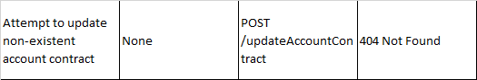
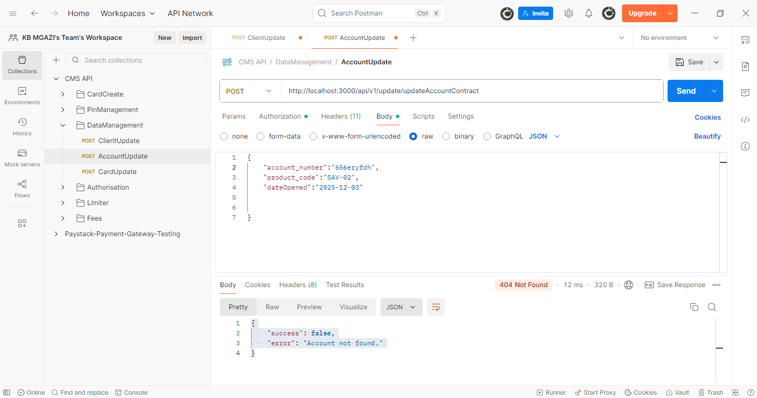
Request:
{
"account_number":"656eryfdh",
"product_code":"SAV-02",
"dateOpened":"2025-12-03"

}

Response:
{
"success": false,
"error": "Account not found."
}

